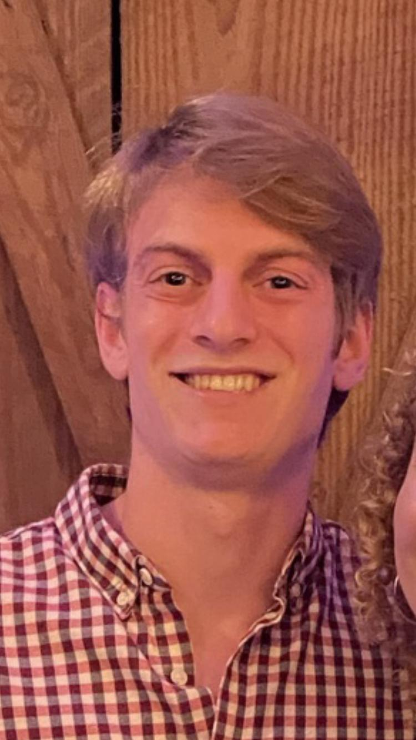 Joseph Kaufman

## SCHOOLS

**College:** Charleston Southern – graduating in May 2023, 3.95 GPA.

Computer and Information Sciences, Business Minor.

**High School:** Nation Ford High School, Fort Mill, SC - 2019 Graduate in Top 12% of Class

FCA Leader, Cross-Country and Track runner

**Career Goal:** Software Developer

## Work Experience

**Summer 2021** Billy Graham Evangelistic Association

**Prior Summers** Chick-fil-A, Pizza Hut, Neighborhood Lawn Mowing Service

## Technology Courses

**College:**

Business Application Programming (Visual Basic) Grade A

Procedural Programming (C++) Grade A

Object Oriented Programming (Java) Grade A

Survey of Scripting Languages Grade A

(Python, Pearl, JS, PowerShell, BASH)

Data Structures (C++) Spring 2022

Applied Networking Spring 2022

(HTTP, TCP, XHTML, DHTML, MySQL)

Senior Project Design Spring 2022

## ENRICHING EXPERIENCES

**Medals of Courage** – Co-founded with my siblings donating 1800+ leftover medals from marathons to 7 hospitals where nurses give to a child before a scary procedure. Gave medals at the Palmetto School to encourage at-risk students. [Featured CN2 TV news story.](https://www.cn2.com/come-see-me-swag/)

**FCA Grant** – Wrote grant application allowing FCA to purchase clothing essentials for 33 kids at the Children’s Attention Home removed from their homes by DSS due to abuse, neglect or abandonment.

**Palmetto Boys State** – Learned about American government and politics as Nation Ford delegate.

**Congressional Award Program** – Awarded Bronze Certificate Award given by South Carolina congressman for voluntary service (200+ hrs.), personal development (100 hrs.), fitness (200+ hrs.).